Q1. The thermometer drawn below can be used to measure the temperature of the human
body.
This practice paper covers the same content and skills as your actual assessment. It is a useful tool for evaluating how well your revision has gone.
How to use:
- Only try this paper after you have revised in other ways first
- Print the paper off
- Complete it under test conditions: in 45 minutes and with no other materials for help
- Mark yourself using the mark scheme at the end of this document
- Identify any weak areas and revise these parts again
- Try those questions again and see if you can improve your score

If you need help printing this resource or marking advice, feel free to ask your teacher!
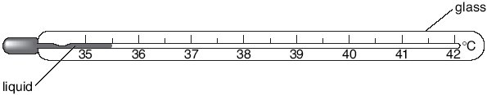
(a) (i) What is the lowest temperature this thermometer can measure?
..............°C
1 mark
(ii) What is the normal temperature of the human body?
Tick the correct box.
37°C 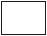 39°C 41°C
1 mark
(iii) When we are ill our temperature may go up.
A nurse can measure a child’s temperature with two different thermometers
as shown below.
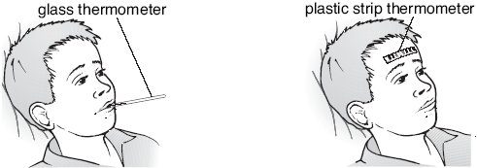

Give one reason why it is safer to use a plastic strip thermometer than a
glass thermometer.
.............................................................................................................
.............................................................................................................
1 mark
(b) Viruses are micro-organisms that can make us ill.
Give the name of one other type of micro-organism that can make us ill.
................................................................
1 mark
(c) Alcohol and mercury are two liquids that can be used in glass thermometers.
The table gives information about these liquids.

liquid | boiling point (ºC) | colour
alcohol | 78 | colourless
mercury | 357 | shiny grey
(i) A red dye is added to the colourless alcohol used in thermometers.
Suggest a reason for this.
.............................................................................................................
.............................................................................................................
1 mark
(ii) Choose words from the list below to fill the gaps in the sentences.
gas liquid solid
When alcohol and mercury boil they both change from a liquid to
a ......................................
1 mark
A thermometer containing mercury can be used to measure the
temperature of an oven at 150°C because mercury is a
....................................... at 150°C.
1 mark
maximum 7 marks

Q2. Nancy is a dancer.

(a) When Nancy dances her arms and legs are moved by pairs of antagonistic muscles.
How do antagonistic muscle pairs work?
Tick the correct box.
Both muscles contract at the same time.
One muscle is big and the other is small.
As one muscle contracts, the other relaxes.
One muscle is strong and the other is weak.
Both muscles relax at the same time.
1 mark

(b) As Nancy dances her breathing changes because she needs more oxygen.
The graph below shows how the volume of air in her lungs changes when she dances.
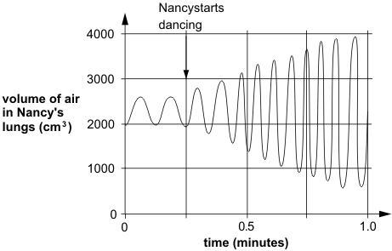
From the graph, give two ways her breathing changes when she dances.
1. ....................................................................................................................
1 mark
2. ....................................................................................................................
1 mark
(c) Nancy’s muscle cells produce carbon dioxide as she dances.
Which of the following shows how the carbon dioxide is removed from Nancy’s body?
Tick the correct box.
muscle cells bloodstream windpipe lungs nose
muscle cells windpipe lungs bloodstream nose
muscle cells bloodstream lungs windpipe nose
muscle cells windpipe bloodstream lungs nose
1 mark
maximum 4 marks

Q3. The drawings below show the trees in a woodland area at the beginning of May and at
the end of May.
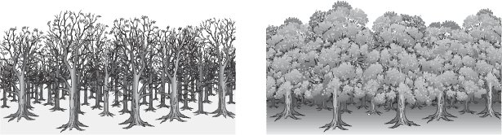
beginning of May end of May
The graph below shows the amount of light reaching the top of the trees and the
woodland floor over one year.
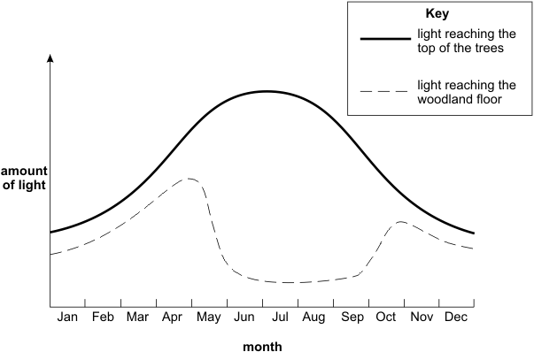
(a) Why does the amount of light reaching the woodland floor decrease during May?
........................................................................................................................
........................................................................................................................
1 mark

(b) Plants grow on the woodland floor.
Explain why these plants grow bigger and faster when there is plenty of light.
........................................................................................................................
........................................................................................................................
........................................................................................................................
........................................................................................................................
2 marks
(c) Respiration takes place in the cells of all plants.
Complete the word equation for respiration.
oxygen + ................................ carbon dioxide + ................................
2 marks
maximum 5 marks
Q4.This question is about three different fuels, A, B and C.
Fuel A is stored in tanks. It is not stored under pressure. It flows along a pipe to where it is needed.
Fuel B is stored under pressure in small cylinders. It is used by campers.
Fuel C can be stored in sacks or bags.
(a) (i) Tick the correct box.
Fuel A is a:
solid
liquid
gas
1 mark
Name a fuel which A could be .............................................................
1 mark

(ii) Tick the correct box.
When fuel B comes out of the cylinder this is a:
solid
liquid
gas
1 mark
Name a fuel which B could be .............................................................
1 mark
(iii) Tick the correct box.
Fuel C is a:
solid
liquid
gas
1 mark
Name a fuel which C could be .............................................................
1 mark
(b) Complete the statement to describe what happens when a fuel burns.
Two waste products formed from burning fuels are
................................................. and .....................................................
2 marks
Maximum 8 marks

Q5. Rema used the apparatus below to distil 100 cm³ of water-soluble ink.
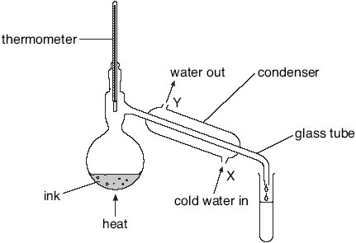
apparatus A
not to scale
(a) Which processes occur during distillation?
Tick the correct box.
condensation then evaporation
evaporation then condensation
melting then boiling
melting then evaporation
1 mark
(b) Give the name of the colourless liquid that collects in the test-tube.
.....................................................
1 mark
(c) What would the temperature reading be on the thermometer when the
ink has been boiling for two minutes?
..............°C
1 mark

(d) (i) Water at 15°C enters the condenser at X.
Predict the temperature of the water when it leaves the condenser at Y.
..............°C
Explain this change of temperature.
.............................................................................................................
.............................................................................................................
1 mark
(ii) Give two ways in which the water vapour changes as it passes down the
glass tube in the condenser.
1. .........................................................................................................
1 mark
2. .........................................................................................................
1 mark
(e) Peter used the apparatus below to distil 100 cm³ of water-soluble ink.
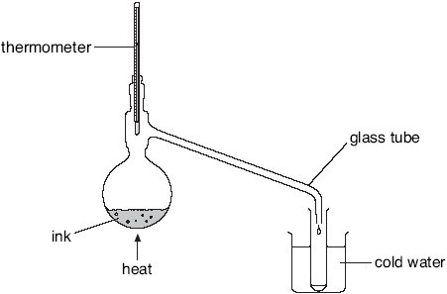
apparatus B
not to scale
Why is the condenser in apparatus A better than the glass tube and beaker of
water in apparatus B?
......................................................................................................................
......................................................................................................................
1 mark
maximum 7 marks

Q6. (a) Many substances burn. Some of them are used as fuels. Some fuels are burned in power stations to generate electricity.
Tick the boxes by the two fuels which are most often burned in power stations.

coal
paraffin wax
natural gas
petrol
paper
2 marks
(b) Burning fuels can pollute the air.
Give two substances which pollute the environment when fuels burn.
1 .................................................................................................................
2 .................................................................................................................
2 marks
(c) Some power stations do not burn fuels. They use other energy resources to generate electricity.
Give two energy resources which are not fuels and which are used to generate electricity.
1 .................................................................................................................
2 .................................................................................................................
2 marks
Maximum 6 marks

Q7.The diagram below shows three trolleys.
Peter put a bar magnet on each trolley.
(a) He pushed trolleys A, B and C together.
• Magnet B attracted magnet A.
• Magnet B repelled magnet C.
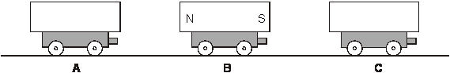
On the diagram above, label the north and south poles of
magnets A and C.
Use the letters N and S.
2 marks
(b) Peter turned trolley B around. Trolleys A and C were not turned around.
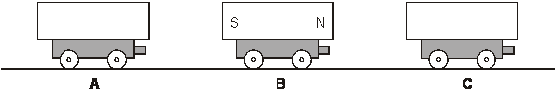
What would happen now when Peter pushed them all together?
Use either attract or repel to complete each sentence below.
Magnet B would .................................... magnet A.
Magnet B would .................................... magnet C.
1 mark
(c) Peter held two trolleys close together and then let go.
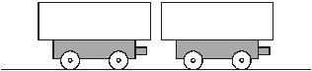
The magnets repelled each other.
Draw an arrow on both magnets to show which way they would move.
1 mark

(d) Peter took a magnet, a steel bar and an aluminium bar.
He put them on three trolleys as shown below.
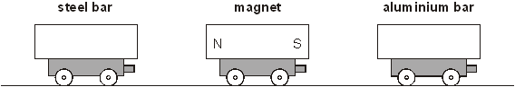
(i) What happens to the steel bar as he moves it closer to the magnet?
...............................................................................................................
1 mark
(ii) What happens to the aluminium bar as he moves it closer to the magnet?
...............................................................................................................
1 mark
maximum 6 marks

Mark schemes
Q1.
(a) (i) 35
1 (L3)
(ii) 37°C
1 (L4)
(iii) any one from
• less chance of micro-organisms being passed on or spread
• glass could break
accept ‘less chance of germs being passed on’
accept ‘might pass on disease’
accept ‘a child might bite or swallow the thermometer’
if more than one box is ticked, award no mark
• mercury or alcohol or liquid could spill
(if the glass thermometer broke)
• mercury is poisonous
• you could choke
1 (L3)
(b) any one from
• bacteria
• fungi
• protozoa
accept a named non-viral pathogenic
micro-organism such as ‘salmonella’
do not accept names of diseases
do not accept ‘germs’
1 (L4)
(c) (i) any one from
• so that alcohol can be seen
accept ‘so you can see it’
• alcohol is difficult to see
• you cannot easily see a colourless liquid
accept ‘you cannot see a colourless liquid’
• to make it easier to read the thermometer
accept ‘so you can read it’
1 (L4)
(ii) • gas
1 (L3)
• liquid
1 (L4)
answers must be in the correct order
[7]
Q2.
(a) As one muscle contracts, the other relaxes.
if more than one box is ticked, award no mark
1 (L5)
(b) any two from
• she gets more air or oxygen
accept ‘greater volume of air taken in or out’
‘she needs more oxygen’ is insufficient
accept ‘breathes out more carbon dioxide’
‘shorter or heavier or louder or harder breaths’ are insufficient
• it gets faster
accept ‘speeds up’ or ‘she takes more breaths’
‘it increases’ is insufficient
• it gets deeper
accept ‘she takes bigger breaths’
‘the volume of air in her lungs increases’ is insufficient
do not accept ‘the volume of her lungs increases’
accept, for one mark, ‘she breathes more’ if not given with
‘it gets faster’ or ‘it gets deeper’
2 (L5)
(c)
muscle cells bloodstream lungs
windpipe nose
if more than one box is ticked, award no mark
1 (L6)
[4]

Q3.
(a) • leaves are bigger
accept ‘there are leaves or a canopy’
accept ‘leaves open or grow’
‘trees block the light’ is insufficient
1 (L5)
(b) any two from
• light is needed for photosynthesis
accept ‘photosynthesis’
• more (photosynthesis)
accept, for two marks, ‘the rate
or amount of photosynthesis increases if the light increases’
• light provides energy for growth
‘they need light to grow’ is insufficient
‘light is a source of food’ is insufficient
• biomass or food or sugar or starch or carbohydrate is produced
2 (L6)
(c) • glucose
1 (L6)
• water
answers must be in the correct order
1 (L6)
[5]
Q4.
(a) (i) liquid
if more than one box is ticked award no mark
accept ‘A’ in the liquid box instead of a tick
1
petrol or oil or diesel
accept a brand name
or paraffin or kerosene
1
(ii) gas
if more than one box is ticked award no mark
accept ‘B’ in the gas box instead of a tick
1
gas or natural gas or calor
accept a brand name
gas or butane or propane
do not accept ‘hydrogen’ or methane or camping gaz
1
solid
if more than one box is ticked award no mark
accept ‘C’ in the solid box instead of a tick
1
coal or coke or wood or charcoal
accept a brand name or ‘peat’
1
(b) any two from
• carbon dioxide
• water accept ‘steam’
• smoke accept ‘soot’
• ash
• gases accept ‘fumes’
• sulphur dioxide accept ‘nitrogen oxides’
• carbon monoxide
do not accept ‘heat’ or ‘energy’ or ‘lead’
2
[8]
Q5.
(a) evaporation then condensation
if more than one box is ticked, award no mark
1 (L5)
(b) water
accept ‘distillate’
1 (L5)
(c) 100
accept a temperature from 99 to 101
1 (L5)
(d) (i) a temperature above 15 but below 100
any one from
• it is heated by the water vapour
accept ‘vapour or steam or hot water’ for water vapour
• thermal energy or heat is transferred from the water vapour
accept ‘it heats up’
both the answer and the correct explanation are required
for the mark
1 (L6)
(ii) any one from
• it condenses
accept ‘it makes condensation’
• it changes to a liquid
accept ‘it is liquid’
accept ‘it changes state’
accept ‘it turns to water’
1 (L6)
• its temperature falls
accept ‘it cools’ ‘it changes temperature’ is insufficient
1 (L6)
(e) any one from
• cold water replaces warm water
accept ‘it cools the water vapour better or more efficiently
or quickly’
accept ‘it will work faster’
• the water stays cold or cooler
• there is a bigger difference in temperature between the water
vapour and the water
• some vapour escapes in B
accept ‘it is cooled over a bigger length or for longer’
accept ‘more water is collected’
1 (L6)
[7]
Q6.
(a) coal
1 (L3)
natural gas
if more than two boxes are ticked, award no mark
deduct one mark for each incorrectly ticked box
minimum mark zero
1 (L3)
(b) any two from
• soot or carbon
• ash
• smoke
• sulphur dioxide
accept ‘sulphur’
• carbon monoxide
• oxides of nitrogen
accept ‘nitrogen oxide’
accept ‘carbon dioxide
accept ‘lead’
accept ‘acid rain’
do not accept ‘greenhouse gases’ or ‘water’ or ‘gas’
2 (L3)
(c) any two from
• geothermal
• wind
• solar
accept ‘Sun’
• running water
accept ‘hydro’ or ‘HEP’ or ‘water power’
• tidal
do not accept ‘water’
• waves
accept ‘nuclear’ or ‘uranium’
2 (L3)
[6]
Q7.
Marks may be awarded for part (a) if the magnets are correctly
labelled in part (b) and no answer is given in part (a)
(a) • Magnet A
both poles are required for the mark
1 (L4)
• Magnet C
both poles are required for the mark
1 (L4)
(b) • repel
• attract
answers must be in the correct order
both answers are required for the mark
1 (L4)
(c) •
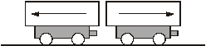
both arrows are required for the mark
1 (L4)
(d) • it is attracted
accept ‘it gets faster’
1 (L4)
• nothing
accept ‘it is not attracted or repelled’
accept ‘it is not attracted’
accept ‘it is not repelled’
‘they stick together’ is insufficient
do not accept ‘it repels’
1 (L4)
[6]

